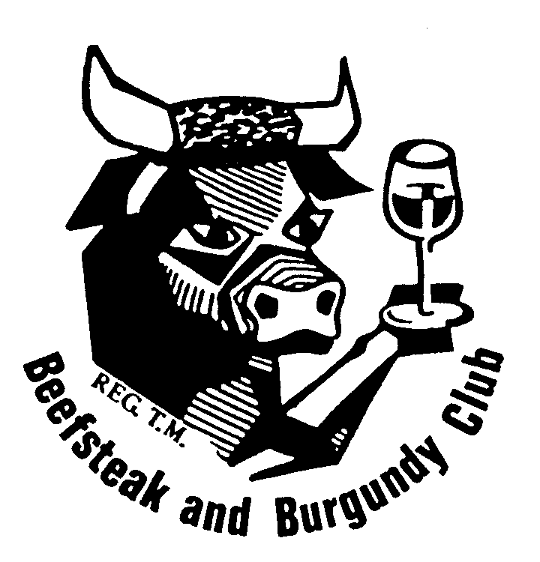 | BURNSIDE BEEFSTEAK & BURGUNDY CLUB  COMMITTEE MEETING  TUESDAY 1 SEPTEMBER 2020  TO BE HELD AT PRESIDENT’S RESIDENCE  14 AVENUE STREET MILLSWOOD  AT 6.00 PM  AGENDA  FOOD: CAROLYN PALMER WINE: CHARDONNAY OR CAB SAV
- Present
- Apologies
Di Betterman

- Minutes of Previous Meeting
- Matters Arising
Nil

- Correspondence
In – Affiliation Fee
Out – August Newsletter; Notification of President and Secretary’s details to the B&B Inc

- Membership
24 active members plus 5 active life members (Bob Bowes, Lee Miller, Leone Scholefield, John Swift and Vin Thomas) plus 1 inactive member (Robyn Quigley) plus 5 inactive life members (Peter Baturin, Bob Brinkworth, Darrol Fullgrabe, Tom Muecke, and Bill Seppelt).

The acceptance of Stephen Thomas as a member was approved by circular email and he is included in the above numbers.

Robyn Quigley has written to the President, seeking another year’s Leave of Absence to be approved. Agreed?

7 Finance Report
8 Cellar Report

9 Functions
  - August (Murton/Palmer)
  - AGM (Bowes)
  - September (Betterman/Keisman)
  - October (Swift/Loxton)
  - November (Mular/Wild)
  - December (Thomas/Gilbert)
10 Any Other Business
a) 2021 Program and Organisers (See below p3)
b) Committee Meetings Venue(s)

c) Matters raised for the Committee’s consideration at the AGM:
The following matters were raised for referral to the Committee:
- When there is a late apology for which the venue charges, the meal should be provided – Peter Murton;
- Organisers of functions need to follow the guidelines and set two additional places – Bob Bowes;
- Places should be reserved at functions for members and their guest(s) – Leone Scholefield;
- If a member has to make a late apology because of a covid reason (test or exhibiting conditions), then the member should not be charged for the function – Leone Scholefield.
d) Food and Wine Roster (Draft below approved?)
e) Public Liability and Directors’ and Officers’ Liability Insurance

Food Roster Wine
September Carolyn Palmer Chardonnay/Cabernet Sauvignon
October Vin Thomas Riesling/Shiraz
November John Swift Gruner Veltliner/Pinot Gris/Grigio/Noir
December Simon Lumsden Semillon/Grenache/Sparkling
January President Arneis/Sauvignon Blanc/Merlot/Malbec
February Di Betterman South Australia
March Tony Scholefield Western Australia
April Saul Gilbert Victoria
May Carolyn Palmer NSW
June Vin Thomas Tasmania
July John Swift International
August Restaurant Members’ choice

11 Ongoing Matters Requiring Implementation
New Directions
- That we contact past members to find out their current situation and if they are interested in attending a future meeting; the recommendation be actioned by the Secretary. That the Club have “past members” nights by special invitation.
- That at least annually the Club have a joint dinner with another Club(s) or invite another Club(s) to join us for our dinner.
- That the Club monitors that it has some themed/ethnic functions, eg: Greek, Italian, French, German, Thai, Vietnamese, Japanese, Chinese, etc.
- That the Club plan to have an annual informal function, eg: BBQ, 'cocktail' function with finger food, etc.
- That the Club invites its function organisers to ensure its food and wine matching choices include more lamb, pork, duck, seafood rather than a focus on beef.
- That the Club lift the focus on increasing wine knowledge by encouraging function organisers to provide more information on the featured wines.

12 Next Meeting: Tuesday 6 October at venue to be determined at 6.00pm

Food in October: Vin Thomas
Wine in October: Riesling/Shiraz

Future Committee Meetings
6 October, 3 November, 1 December, 10 January, 2 February, 2 March, 6 April, 4 May, 1 June, 6 July, 3 August
FUNCTIONS AND ORGANISERS

2020

DATE | FUNCTION | VENUE | ORGANISER | ORGANISER
19 January | Lunch | Lambert Winery | Lee Miller | Ingrid Allison
12 February | Dinner | Stamps | Tim Ryan | Anita Smith
15 March | Presidents Lunch | Mt Osmond GC | Ken Ridley | (MP) Saul Gilbert
19 April | Lunch | Cancelled | Carolyn Palmer | Peter Murton
13 May | Dinner | Cancelled | Simon Lumsden | Bob Bowes
10 June | Dinner | Cancelled | Di Betterman | Jeremy Keisman
8 July | Dinner | Martini Restaurant | Simon Lumsden | Bob Bowes
12 August | Gourmet | Treasury 18 | Carolyn Palmer | Peter Murton
22 August | AGM | Living Choice | Committee | (NT) Bob Bowes
9 September | Dinner | Sprout Café/Rest’nt | Di Betterman | Jeremy Keisman
16 October | Better Bottle Night | Kooyonga GC | John Swift | Hayden Loxton
11 November | Dinner |  | Taras Mular | Jenny Wild
9 December | Gourmet |  | Vin Thomas | Saul Gilbert
Spare: John Cruickshank, Judy Hani, Charles McPhee, Lorraine Curtis, Tony Scholefield

2021

DATE | FUNCTION | VENUE | ORGANISER | ORGANISER
17 January | Winery Lunch |  | Hayden Loxton
10 February | Dinner |  | Lee Miller
14 March | President’s Lunch |  | Ken Ridley | (MP)
14 April | Lunch |  | Lorraine Curtis
12 May | Dinner |  | Jeremy Keisman
9 June | Dinner |  | Charles McPhee
14 July | Gourmet Dinner |  | Judy Hani
11 August | Dinner |  | Raylene Sutton
21 August | AGM |  | Bob Bowes | (NT) Simon Lumsden
8 September | Dinner |  | Taras Mular
13 October | Dinner |  | Kent Makin
13 November | Lunch |  | John Cruickshank
8 December | Gourmet Dinner |  | Leone Scholefield

Committee to be assigned: Vin Thomas, John Swift, Di Betterman, Carolyn Palmer, Saul Gilbert, Tony Scholefield
Members not as yet assigned: Ingrid Allison, Tom Mittiga, Peter Murton, Sue Robinson, Tim Ryan, Anita Smith, Stephen Thomas, Jenny Wild, Rene Young

